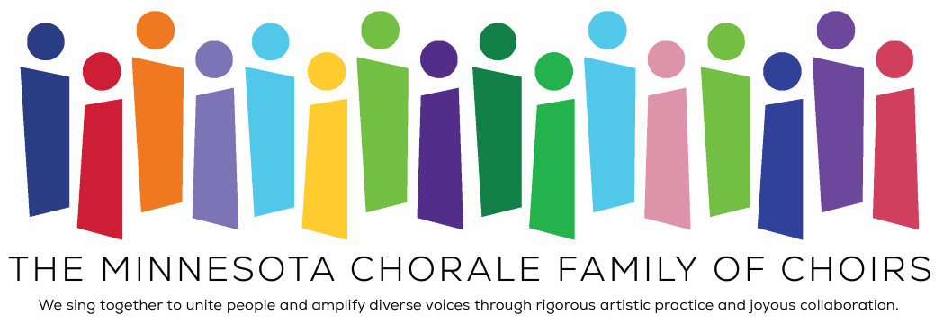
MOCK PROGRAMMING EXERCISE TO COMPLETE

With ensembles for singers from ages 8 to 80-plus, the Minnesota Chorale is a multi-generational umbrella organization composed of the original Symphonic Chorus and these three ensembles:
- Minneapolis Youth Chorus : established in 2007, this is our choral opportunity for Minneapolis students in grades 6 through 8 to develop their musical gifts in an environment dedicated to the celebration of diversity and the pursuit of artistic excellence.
- Prelude Children's Choir: established in 2012 for children in grades 3 through 5; provides an introductory choral experience for younger singers.
- Voices of Experience : established in 2010 in partnership with the MacPhail Center for Music, offers mature singers’ opportunities to achieve vocal excellence and enrich the community through song.
Each season we bring the four choirs together in a Family of Choirs Celebration Concert.
For this portion of the application, we would like you to demonstrate how you would program this concert based on theme and pieces selected by the other choirs.
MOCK FAMILY CONCERT THEME: Immigration and Belonging
Prelude Repertoire:
- Two Bobobo Songs – Traditional Songs of Ghana - arr. Karen Howard & Rob McHugh
- Vuela by Carlos Cordero
Minneapolis Youth Chorus Repertoire:
- Nine Hundred Miles - arr. Philip Silvey
- De Colores - arr. Natalia Romero Arbeláez
Combined Youth Choirs Repertoire:
- Stand Together by Jim Papoulis
Voices of Experience Repertoire:
- Until Love is Spoken by Karen Marrolli
- Belong by Jocelyn Hagen
- “Make Them Hear You” from Ragtime lyrics by Lynn Ahrens, Music by Stephen Flaherty, arr. Mark Hayes
- Border by Rich Campbell

Please complete the chart below by selecting 3 pieces for the Symphonic Chorus and 1 piece for the combined choirs to perform and explaining why each piece was chosen.

Title & Composer/Arranger | Explanation
Symphonic Chorus:
Symphonic Chorus:
Symphonic Chorus:

Combined Choirs:

